IMDB Movies — Problem Queries Report
PRSQL-01 Capstone
13 Required SQL Questions, Results & Insights
Prepared by: Sauravi Sarode.
Batch / Team: PTID-CDA-SEP-26-11277
Date: 06-10-2026
Database: project_movie_database | Tables: movies, directors

Problem Queries
Q1. Can you get all data about movies?
SQL Query
USE project_movie_database;
SELECT COUNT(*) AS movie_table_count FROM movies;
SELECT * FROM movies;
Result

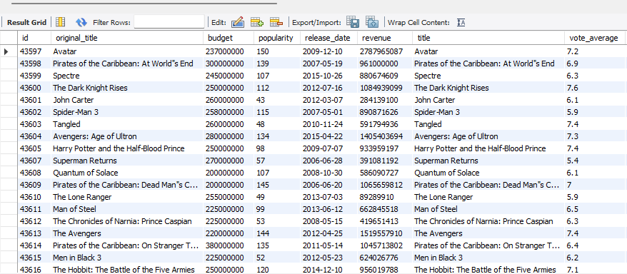

Result: 47 total movie records retrieved
Insight: The movies table holds a focused set of 47 well-known titles, not an exhaustive movie catalog - this looks like a curated sample of notable blockbuster films, which fits the kind of “most popular / most bankable” questions asked later.
Q2. How do you get all data about directors?
SQL Query
SELECT COUNT(*) AS directors_table_count FROM directors;
SELECT * FROM directors;
Result


Result: 2,349 total director records retrieved
Insight: The directors table is roughly 50 times larger than the movies table (2,349 directors vs 47 movies). This confirms it's a broad industry reference list, not a list limited only to directors of the 47 analyzed movies - important context for every director-level statistic that follows.
Q3. Check how many movies are present in IMDB?
SQL Query
SELECT COUNT(*) AS movie_table_count FROM movies;
Result
Result: 47
Insight: Confirms the dataset size. Because the sample is small (47 movies), any percentage-based finding later in this report - such as gender splits - should be read with that small sample size in mind.
Q4. Find these 3 directors: James Cameron; Luc Besson; John Woo
SQL Query
SELECT * FROM directors
WHERE name IN ('James Cameron', 'Luc Besson', 'John Woo');
Result

Result: All 3 directors found - each listed with gender = 2 (Male), department = Directing
Insight: All three directors are confirmed present and are recorded as male in the Directing department - consistent with the broader male skew found across the dataset in later questions.
Q5. Find all directors with name starting with S
SQL Query
SELECT * FROM directors
WHERE name LIKE 'S%';
Result

Result: 20+ directors found, including Steven Spielberg, Sam Mendes, Sam Raimi, Sylvester Stallone
Insight: Every director returned in this alphabetical slice is male (gender = 2) - no female director's name happens to start with “S” in this dataset. A small early signal of the larger gender imbalance confirmed in Q6.

Q6. Count female directors (gender: 0/2 = Male, 1 = Female)
SQL Query
SELECT COUNT(*) AS female_director_count
FROM directors
WHERE gender = '1';
Result

Result: 150 female directors
Insight: 150 of 2,349 total directors (6.39%) are recorded as female - a clear minority at the director-reference level. This gap becomes far more significant when looking at which directors are actually linked to the 47 movies in this dataset (see Q11).
Q7. Find the name of the 10th first women director
SQL Query
SELECT name FROM directors
WHERE gender = '1'
ORDER BY id ASC
LIMIT 9, 1;
Result

Result: Angelina Jolie
Insight: Angelina Jolie appears early in the ordered list of female directors by ID, indicating her record was one of the earlier female-director entries added to the dataset. As a publicly known actress-turned-director, this is also a useful sanity check that the dataset's names are accurate.
Q8. What are the 3 most popular movies?
SQL Query
SELECT * FROM movies
ORDER BY popularity DESC
LIMIT 3;
Result


Result: Jurassic World (418), Captain America: Civil War (198), Avatar (150)
Insight: All three are major studio franchise/blockbuster releases. This suggests “popularity” in this dataset correlates strongly with big-budget franchise films rather than smaller, critically acclaimed releases.
Q9. What are the 3 most bankable movies? (bankable = highest profit, revenue − budget)
SQL Query
SELECT title, budget, revenue, (revenue - budget) AS profit
FROM movies
ORDER BY profit DESC
LIMIT 3;
Result

Result: Avatar ($2.55B profit), Titanic ($1.65B), Jurassic World ($1.36B)
Insight: Two of the three most bankable movies (Avatar, Jurassic World) also appear in the most popular list (Q8) - showing popularity and profitability do overlap at the very top of the dataset, even though the two rankings diverge further down.
Q10. What is the most awarded average vote since January 1st, 2000?
SQL Query
SELECT title, release_date, vote_average
FROM movies
WHERE release_date >= '2000-01-01'
ORDER BY vote_average DESC
LIMIT 1;
Result


Result: The Dark Knight Rises (2012) - vote_average 7.6
Insight: This is also the dataset's single highest-rated movie overall (not just since 2000), meaning no pre-2000 movie scored higher. Worth double-checking by re-running the same query without the date filter to confirm no earlier film ties or beats this score.

Q11. Which movie(s) were directed by Brenda Chapman?
SQL Query
SELECT m.original_title, m.title, m.director_id, d.name AS director_name
FROM movies AS m
JOIN directors d ON m.director_id = d.id
WHERE d.name = 'Brenda Chapman';
-- Follow-up checks run to confirm the empty result:
SELECT * FROM directors WHERE name = 'Brenda Chapman';
SELECT * FROM movies WHERE director_id = 4801;
“No movies in this dataset are linked to Brenda Chapman (director ID 4801); the directors table includes her as a reference entry, but no corresponding movie record exists."

Result


Result: No movies found - empty result set
Insight: This is a genuine data finding, not a query error. Brenda Chapman exists in the directors reference table (ID 4801) but has zero linked movies in the 47-movie dataset. This directly supports the larger finding that 0% of the 47 movies were directed by a woman.
Q12. Which director made the most movies?
SQL Query
SELECT d.name AS director_name, COUNT(m.id) AS movies_count
FROM movies AS m
JOIN directors d ON m.director_id = d.id
GROUP BY director_name
ORDER BY movies_count DESC;

"Three directors are tied for the most movies in the dataset, each with 3 films: Gore Verbinski, Sam Raimi, and Peter Jackson."

Result


Result: 3-way tie: Gore Verbinski, Sam Raimi, Peter Jackson - 3 movies each
Insight: No single director dominates the dataset's volume - the top spot is a 3-way tie, and most directors in the full result set directed only 1 movie each. This shows a long tail of one-off entries alongside a small group of repeat studio directors.

Q13. Which director is the most bankable? (bankable = highest total profit across all their movies)
SQL Query
SELECT d.name AS director_name, SUM(m.revenue - m.budget) AS total_profit, COUNT(m.id) AS movies_count
FROM movies AS m
JOIN directors d ON m.director_id = d.id
GROUP BY director_name
ORDER BY total_profit DESC
LIMIT 1;
Result

Result: James Cameron - $4,195,999,275 total profit, from 2 movies
Insight: James Cameron achieves the highest total profit from only 2 movies - fewer than the Q12 leaders (3 movies each). This shows total bankability here is driven by the size of individual hits (Avatar, Titanic), not by sheer number of movies directed.

